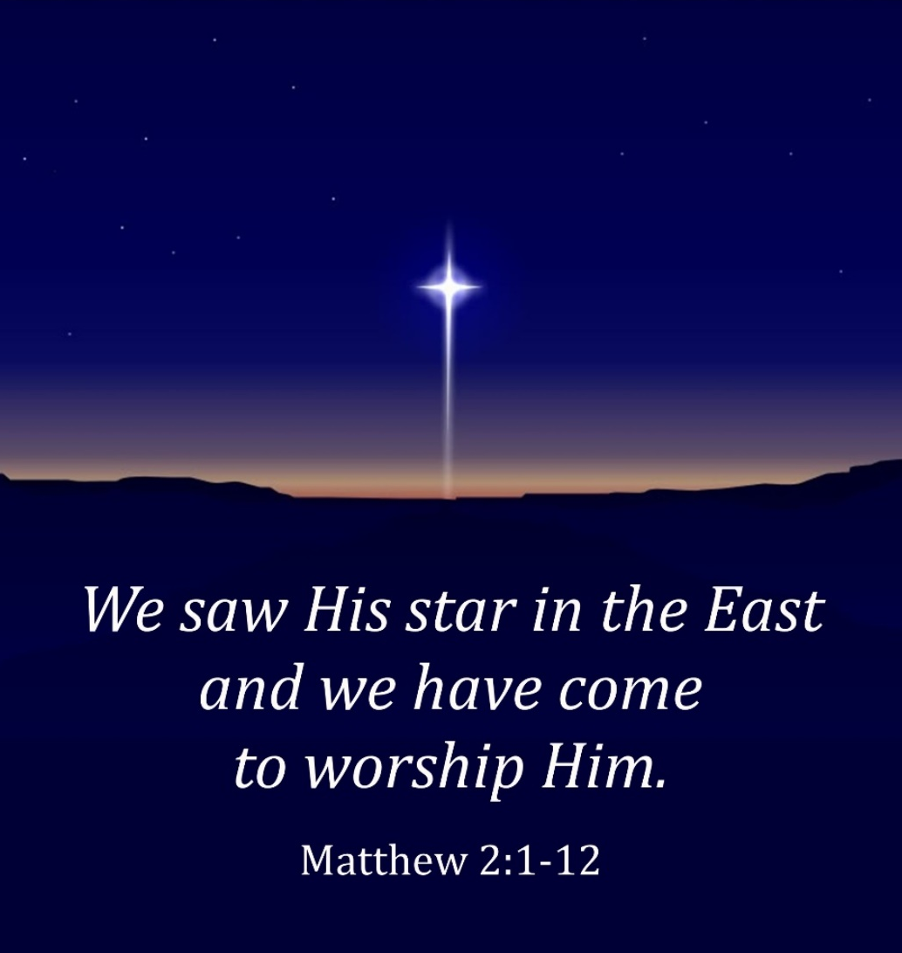

The Sword of the Spirit
Week of Prayer for
Christian Unity

January 18-25, 2022

Table of Contents

Introduction 1
Day 1: Tuesday, January 18 2
Christian Witness: Growing in Unity 3
Day 2: Wednesday, January 19 5
Christian Witness: Open to the Holy Spirit 6
Day 3: Thursday, January 20 7
Christian Witness: Strong Collaboration 8
Day 4: Friday, January 21 10
Christian Witness: What Unites Us 11
Day 5: Saturday, January 22 12
Prayer for the Lord’s Day 14
Day 6: Sunday, January 23 14
Christian Witness: Children of One Father 15
Day 7: Monday, January 24 17
Christian Witness: Fully Committed 18
Day 8: Tuesday, January 25 20
Christian Witness: I Cannot but Thank God 21

Imprimatur, Archbishop Georges Bacouni,
Greek Catholic Archbishop of Beirut and Byblos.

Introduction
In the gospel of Matthew, we are presented with the statement that wise men, drawn to the light of a star, declared: "We saw His star in the East and we have come to worship Him" (Matthew 2:2). To this day people are still drawn to the light of that start, the light of Christ.
This year the week of Prayer for Christian Unity takes Matthew 2:2 as its theme to both celebrate the Christian Churches of the East and to raise awareness of their present situation and to stand with them in prayer.
While in the West, ecumenism exists primarily between the Roman Catholic Church and the Protestant Churches, ecumenism in the Middle East is primarily between the different Catholic Churches and the different Orthodox Churches.
Our Sword of the Spirit communities in the Middle East, for example, have Catholic members from seven Catholic “rites”: the Maronites, the Greek Catholics, the Armenian Catholics, the Syriac Catholics, the Chaldean Catholics, the Coptic Catholics and the Latins (called Roman Catholics in the West), and from three self-governing Orthodox Churches: the Greek Orthodox, the Syriac Orthodox and the Armenian Orthodox. We do not yet have members from the Coptic Orthodox Church, the largest church in the Middle East (primarily in Egypt), or the Ethiopian Orthodox Church or the Assyrians (primarily in Iraq).
This booklet will shed light, though in a brief manner, on a few of these Middle East Churches through personal testimonies. May it help us appreciate more the diversity of Christian realities that God has allowed in order that we see His beauty through the mosaic of them all, and to continue to pray that through this diversity we all attain this kind of unity in love so that those Muslims and Jews and atheists and others may know that we are the disciples of our Lord and God Jesus Christ.

Day 1: Tuesday, January 18
Matthew 2:2 “We saw His star in the East.”
Raise us up and draw us to your perfect light.
Reading: 2 Timothy 1:7-10 This grace… has now been revealed through the appearing of our Savior Christ Jesus.
Reflection: In this fragile and uncertain world, we look for a light, a ray of hope from afar. In the midst of evil, we long for goodness. We look for the good within ourselves, but so often we are overwhelmed by our weakness that hope fails us. Our confidence rests in the God we worship. God, in his wisdom, enabled us to hope for divine intervention; but we had not anticipated that God’s intervention would be a person, and that the Lord himself would be the light in our midst. This exceeded all our expectations. God’s gift to us is a “spirit of power, and love.” Not by relying on our own strength and ability are we drawn forward on the way to this perfect light, but rather by God’s Holy Spirit.
In the midst of humanity’s darkness, the star from the East shone. In it we see a light that penetrates the depths of the darkness that separates us from one another. The star’s light was not only an illumination at a particular historical moment, but it continues to shine and change the face of history. Throughout the ages, and ever since the star first appeared, the world has come to know through the lives of Christ’s followers the hope that is inspired by the Holy Spirit. These give witness to God’s work in history, and to the abiding presence of the Holy Spirit. Despite the changing circumstances of history, the Risen One continues to shine, moving within the flow of history like a beacon guiding all into this perfect light and overcoming the darkness which separates us from one another.
Our desire in the Sword of the Spirit to overcome the darkness that separates us compels us to pray and work for Christian unity.
Prayer: Heavenly Father, illumine our path by the light of Christ who moves before us and leads us. Enlighten us and dwell within us. Creator of light, we thank you for the gift of that unfading Star, Jesus Christ, our Lord and Savior. May he be a beacon for our pilgrimage, heal our divisions, and draw us closer to the Light of Christ that we may find our unity in him. Amen.

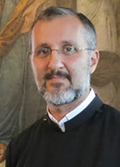
Christian Witness: Growing in Unity
Archpriest Drtad Uzunyan has been serving for more than 30 years under the Armenian Orthodox Patriarchate of Turkey.
The Armenian Church was founded in 301 by Saint Gregory the Illuminator and Saint King Drtad III. In this respect, it went down in history as the first nation to embrace Christianity and has a 1700-year history. The Armenian Patriarchate of Turkey, where I serve, was established in 1461. Patriarch Sahak II is the 85th Patriarch of the Armenians of Turkey.
In 1989, I decided to follow Lord Jesus Christ by starting to read the Bible that a friend had given me. To better understand God’s Word, I participated in a youth Bible study group led by Bishop Mesrob, who would later become the 84th Armenian Patriarch of Turkey. I met my wife Tanya in that same Bible study group, and we were married in 1995. In that year I was also consecrated as a married Priest.
The Armenian Orthodox community in Turkey is the biggest Christian population in Turkey, and it has always taken a leading role among the Christian churches, especially in fostering ecumenical collaboration. By the efforts and close cooperation of the late Patriarch Mesrob II and the Ecumenical Patriarch Bartholomew, the ecumenical life in Turkey was raised to a higher level. In 2003, by the proposal of the two patriarchs and by the participation of the traditional church bishops and mainstream Protestant church leaders in Turkey, the Joint Commission of Churches in Turkey was established. The work of this commission opened a new ecumenical path for the local churches, and a very significant contribution of the Commission was the publication of a book on common faith principles Christianity: Fundamental Teachings. For the first time in history, Orthodox, Oriental Orthodox, Catholic and Protestant leaders signed a document which shows the common faith of all Christianity (see Garo Saraf’s contribution for more about this).
Another commission yearly organizes the Week of Prayer for Christian Unity, which has been going on for 35 years. This has created an environment in which the various churches can interact with one another and serve together. Both commissions, of which I am the vice president, continue their work and plan to create further ecumenical initiatives.
The Istanbul Interparish Refugees Program, which has been serving refugees for years, is yet another fruit of the ecumenical environment that has been created.
Recently, consultations between Traditional Churches and the Union of Protestant Churches in Turkey have started, and efforts are being made to create a fraternal space for further dialogue. This aims to promote Christian dialogue between Free Churches and Traditional Churches in Turkey at an official level and to establish an atmosphere of mutual respect, love, and cooperation. I recommend the ecumenical environment in Turkey as a good model of cooperative ecumenism in the world. We are trying to develop ways to resolve existing problems, conflicts and deepen mutual understanding and connectedness.
The city where two very significant separations of churches took place (in 451 at the Council of Chalcedon and in the Great Schism of 1054) – this city is currently becoming a good model of growing Christian unity among the small remnant of Christian presence, in the vast sea of a Muslim country.
Remember us in your prayers, remember our church leaders, that we may walk and serve in unity, pleasing our Lord’s heart, as he prayed: “Holy Father, protect them by the power of your name, the name you gave me, so that they may be one as we are one” (John 17:11).
May the Lord protect us by the power of his Name and make us one. Amen.

Day 2: Wednesday, January 19
Matthew 2:2 “Where is He who has been born king of the Jews?”
Humble leadership breaks down walls and builds up with love.
Reading: Matthew 20:20-28 The Son of Man came not to be served, but to serve.
Reflection: Jeremiah denounces the bad leadership of the kings of Israel who divided and scattered the people (Jeremiah 23:1-6). Theirs was a leadership that destroyed nations and drove Israel’s citizens into exile. In contrast, the Lord promises a shepherd-king who will “execute justice and righteousness in the land” and gather the members of his flock.
Our world craves good leadership and is constantly seeking someone who will fulfill this desire. Where can one find such a leader? Only in Christ have we seen the example of a king or leader after God’s heart. As we are called to follow him, we are also called to emulate his way of servant-kingship in the world, in the Church and in the way we serve each other in our community life. In Christ we encounter one who does not tear down and divide but builds up and makes whole for the glory of God’s name. His rule is not self-serving, and he does not use force. Rather in him we encounter a loving, humble servant who does not regard equality with God as something to be exploited. He is one who comes to serve, rather than be served, and his followers are called to do the same.
Today, the Middle East is experiencing the loss of its people to exile as “righteousness and justice” are becoming scarce commodities, not only there but throughout the world. Yet we have a hope that will not be shaken even if “the nations are in an uproar” and “the kingdoms totter” around us.
Leaders, both in the world and in the Church, have responsibility to bring together rather than to scatter or divide the people of God. So much division in the world and in the Church is caused by the desire for position, power, and self-advantage. The more faithfully we, as Christians, emulate the servant leadership of Christ, the more division in both the world and the Church will be overcome.
Prayer: God, our only bulwark and strength, we glorify you for you are a just and righteous God. Help us to humbly seek our Lord Jesus Christ and to emulate him in his meekness. Encourage us to empty ourselves as we serve our brothers and sisters in obedience to you. We pray in the name of Christ who with you and with the Holy Spirit reigns forever in glory. Amen.

Christian Witness: Open to the Holy Spirit
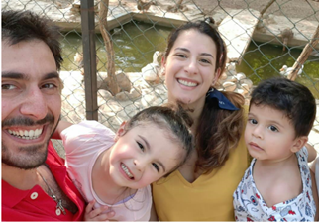
Julien Jalkh and his wife Nadine are members of the People of God community in Beirut and attend a Maronite church.
At the end of the fourth century, between the cities of Aleppo and Antioch in what is now modern-day Syria, the priest and hermit Maron, a friend of John Chrysostom, was leading a life of prayer and simplicity. This inspired many to be his disciples. Maron did not leave behind theological or philosophical works but established an informal spiritual monastic-hermitic school that is still flourishing today. After the Council of Chalcedon (451A.D.), Maron’s disciples (eventually called “Maronites”) built a monastery (Bet Maron – House of Maron) which became a rallying and reference point in the area for Chalcedonian Christians (this predates the East-West schism, which gave us Eastern Orthodox and Catholics). The Maronites (lay people and clergy) gathered around this and other monasteries living an austere life in the mountains and eventually in the rest of the world.
The Maronites have faced persecution since the very first day of their existence, hence their presence initially in the mountains which provided a natural bulwark. The continual persecution influenced the Maronite liturgy which reflects simplicity, connection with land, and other characteristics of this Syriac Eastern Catholic Church. Persecution also led to the presence of a wide diaspora of Maronites in different regions of the world. The Maronite Church has dioceses in North America, South and Central America, Europe, Africa, Asia, and Oceania.
Since the fifth century, Maronites have gathered in the Qadisha Valley (in modern day Lebanon) and have established there hermitages, convents, monasteries, and churches which they have shared with other Christians in the area: Syriac, Byzantine, Ethiopian Orthodox, etc. And even in our day, the Maronite Church has been taking various ecumenical initiatives on the national and regional level.
After coming alive in my faith, I had the opportunity to discover the beauty and depth of my church, officially known as the Syriac Maronite Church of Antioch. I experienced how my church fuses Eastern traditions (while being in communion with the Western Catholic Church) with a remarkable openness to the Spirit, ready to change in order to reach out to the youth of today and meet their needs while maintaining its ancient rich liturgical tradition. I also learned from my church to connect more to my land and understood that we have an integral role in being salt and light in Lebanon in particular, and in the wider Middle East.

Day 3: Thursday, January 20
Matthew 2:3 “When king Herod heard this he was disturbed, and all Jerusalem with him.”
The presence of Christ turns the world upside down.
Reading: Nehemiah 4:18-21 So we labored … from break of dawn until the stars came out.
Reflection: The Lord has come amongst us. Christ’s coming disturbs the ways of the world. In contrast to so many national leaders, the Lord comes in humility denouncing the evil of injustice and oppression that accompanies the ambition for power and status. The coming of Jesus calls for a change of heart and a transformation of life, so that people will be liberated from all that dehumanizes them and causes them suffering. Jesus shows us that God is with those who suffer because each person has a dignity as God’s beloved child. Thus, Jesus’ presence creates disturbance precisely because he rocks the boat of the rich and the powerful who work only for their own interests and neglect the common good. But, for those who work for peace and unity, Christ’s coming brings the light of hope.
When Christians work together for justice and peace, our efforts are more powerful. The answer to our prayer for Christian unity is made visible through us so that others can recognize Christ’s presence in the world today. By our words and actions, we can bring the light of hope to so many who are still living in the darkness of political unrest, poverty, and unjust discrimination. The Good News is that God is faithful, and he is always the one strengthening us and protecting us from harm and inspiring us to work for the good of others, especially those living in the darkness of suffering, hatred, violence, and pain.
Prayer: O Lord, you have guided us out of darkness to Jesus. You have illumined the star of hope in our lives. Help us to be united in our commitment to bring about your reign of love, justice, and peace, and be a light of hope to those living in darkness, despair, and disillusionment. Take our hand, Lord, so we can see you in our daily lives. As we follow you, remove our fear and anxiety. Shine your light upon us and set our hearts on fire with your love. Lift us up to you, you who have emptied yourself for our sake, so that our lives may glorify you, Father, Son and Holy Spirit. Amen.

Christian Witness: Strong Collaboration
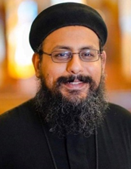
My name is Fr. Mina Dimitri. I am a priest of the Coptic Church whose historic name is the Church of Alexandria. The Pope of my Church resides in Egypt, where the largest population of Copts exists. St. Mark, the evangelist, established the Church. Many well-known church fathers have come from this church including Origen, St. Clement of Alexandria, St. Athanasius, and St. Cyril. The Church was persecuted for much of its existence. It offered many martyrs throughout its history.
The monastic life, founded in Egypt by St. Anthony the Great, continues to be an instrumental part of the Coptic Church today.
The present leader of the Church is Pope Tawadros II who was elected in 2021. There are about 20 million Coptic Orthodox in Egypt. There are Coptic churches on all continents. In New Jersey and New York alone, we have over 55 churches. In the United States, we have about 13 bishops and hundreds of priests. This is a significant expansion. In the 1960s the Church only had two priests in North America.
The Coptic church in Egypt is everything for the Christian. It is where they play sports, serve, pray, share their concerns as well as vacation together. I used to spend at least 6 days a week in the church. Whenever I was bored, I would simply walk to the church. It is like a home to all of us. It is probably because Christians for the longest time felt that they couldn’t obtain access to the same facilities as their Muslim brothers and sisters, so the church became our home.
I was raised and have been a member of the Church all my life. It is hard to define a specific moment as a transformative point, but I must say meeting a couple of the “mystic fathers” in the deserts of Egypt was a significant light in my life. One of the desert fathers I met had the grace of reading my thoughts, which was overwhelming but wonderful
In Egypt there is a lot of collaboration among the various Christian communities especially between the Catholic and Coptic churches. There is a strong collaboration among many of the churches since most of the dioceses have one bishop, and most bishops have monthly meetings for the clergy to discuss the issues and work together. But I also believe that the Church has a lot of work to do in this area.

Day 4: Friday, January 21
Matthew 2:6 “And you, Bethlehem… are by no means least.”
Though small and suffering, we lack nothing.
Reading: Micah 5:2-5a, 7-8 From you shall come forth…one who is to rule in Israel.
Reflection: From the small and lowly city of Bethlehem, the Lord, the Son of God, made his entrance into the world. From the womb of a humble village girl, he took human flesh, and chose to live his humanity in obscurity and simplicity. He became a small ray of light to our eyes, and that light has filled the earth. Out of the obscurity of Bethlehem has come a ruler, the shepherd and guardian of our souls. And though he is our shepherd, he became the Lamb who carried the sins of the world that we might be healed.
Though of little significance among the great clans of Judah, Bethlehem was made great because of the birth of the Shepherd of all shepherds, the King of all kings. Bethlehem, a name that means the “house of bread,” can be a metaphor for the Church that brings to the world the bread of life. The Church, the Bethlehem of today, continues to be the place where the weak, the powerless and the small are welcome because in her each has a place. The gathering of these grains becomes the harvest. The united yeast becomes a powerful force. The concentrated rays become a guiding light.
In the midst of political turmoil, a growing culture of greed, and the abuse of power in this world, Christians, like others in the Middle East, suffer persecution and experience a sense of marginalization, living in fear of violence and injustice. Yet, Christians, face this fear with hope proclaiming that the Shepherd walks with them, gathering them into one fold and making them a sign of his loving presence. United, they are the yeast that leavens the batch. In Christ they find a model of humility, and from him they hear a call to overcome divisions and to be united in one flock. Though they are few, in their suffering they follow in the steps of the Lamb who suffered for the world’s salvation. Though few they are sure in hope, lacking nothing.

Prayer: Good Shepherd, the fragmentation of the little flock grieves your Holy Spirit. Forgive our weak efforts and slowness in the pursuit of your will. Give our communities wise shepherds after your own heart who will lead us with righteousness and holiness, to unity in you. We ask you, Lord, to hear our prayer. Amen.

Christian Witness: What Unites Us
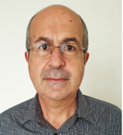
I am Garo Saraf, 55 years old, and a member of the Armenian Apostolic Orthodox Church in Istanbul, a church with a history and tradition of 1700 years, with rich spirituality, liturgy, and teaching, passed down from Christ’s Apostles and the Apostolic Fathers.
Following my late father’s guidance since early childhood, I had taken tiny steps which have led to active participation in the life and service of my church.
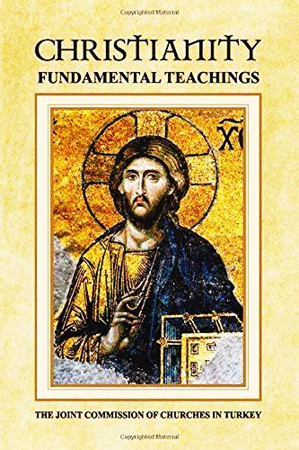
But I still lacked a personal connection with the Living God, that is until 15 years ago when I was invited to a Life in the Spirit Seminar by my parish priest, Fr. Drtad Uzunyan. This was a turning point in my spiritual life as well as in my whole presence and service within the church’s life and liturgy. All of these became much more alive and life giving.
Amongst many other services, I was privileged to participate in my Church's ecumenical efforts. In this context, I worked on a sub-committee of the Joint Commission of Churches in Turkey to translate into English a book called Christianity: Fundamental Teachings.
Istanbul is one of Christendom’s most important cities. From very early on in the Christian era, this city has been a center of teaching and leadership, and this has influenced many Christian nations. Ecumenical councils, which determined the foundational doctrines of Christianity were held there or organized in the city. Even today, the city has maintained a Christian presence, though a much smaller one. The multi-ethnic mosaic of Greek, Armenian, Syriac, Latin, Chaldean, and Turkish churches, representing every major Christian tradition, displays a vitality that could be a living example for the whole Christian world. These sister churches that come together on various occasions have initiated many collaborative projects and events. The book above is one of the fruits of such efforts.
At first, this book was written in Turkish by our Armenian Patriarch Sahak II in his role in the Joint Commission of Churches in Turkey. Then this commission deemed appropriate that it be translated into English, in order to make it available to the wider Christian world. A sub-committee was formed, and I was there representing both Armenian and Syriac Orthodox churches.
Through this book, all the major churches in Turkey send an important reminder and message to the whole Christian world: what unites us is incomparably greater than what divides us.
As our Patriarch stated in the introduction to the English version of the book: It is time to stop looking at the black dot on the white sheet and look at the whole page.
May the Lord give us all the love and wisdom to do this!

Day 5: Saturday, January 22
Matthew 2:9 “The star which they had seen in the East went before them.”
Guided by the one Lord
Reading: Exodus 13:17-14:4 The Lord went in front of them in a pillar of Cloud.
Reflection: Again and again the scriptures tell us how the Lord God walks with his people, protects them, and watches over them day and night. The path may not always be straight: sometimes we are led to retrace our steps, and at other times to return by a different route. But in all our journeying through life, we can be confident that God, who neither “sleeps nor slumbers” protects us lest our feet slip and we fall.
Even in the greatest darkness, God’s light is with us. His light shines out through the prophets sent to guide God’s people on the way set before them and to remind them of the covenant. Most perfectly, in the fullness of time, God sent his only begotten Son, Jesus Christ. He is the guiding light for all nations, the glory of God in the world, the source of divine life, sealing a new covenant in his blood.
In the Sword of the Spirit, we see that the way ahead into unity with one another – and so into closer union with Christ – is not always clear. In our earnest attempts to build unity ourselves, it is all too easy to lose sight of this fundamental message of the scriptures: that God does not abandon his people even in their failures and divisiveness. Not only is this a message of hope for Christians, but for the whole world. As the story of the Magi reminds us, God guides people of all kinds, with the light of the star, to where Christ, the light of the world, is to be found.
God sends the Holy Spirit whose light enables us to see with the eyes of faith the truth of the divine Child, and the call to unity and the reconciliation of all things in him. It is this Spirit that leads us from darkness and tragedy into Christ’s light and life.
Prayer: O Lord God our Father, you sent the star to lead the Magi to your only begotten Son. Increase our hope in you and let us know at all times that you are walking with us, watching over your people. Teach us to follow the guidance of your Holy Spirit, so that we may be led to our unity in Jesus Christ, the light of the world. Open our eyes to your Holy Spirit, and encourage us in our faith, so that we may confess that Jesus is Lord, and worship and rejoice in him as the Magi did in Bethlehem. We ask you these blessings in the name of your Son Jesus Christ. Amen.

Prayer for the Lord’s Day
This prayer may be used after the Blessing of the Wine, similar to the seasonal variations in the Lord's Day Opening Ceremony.
Leader: Let us thank Him this day especially for the unity we enjoy in the Body of Christ and for our call to ecumenical life in the Sword of the Spirit. May we all become perfectly one, so that the world may know and believe. Lord our God, You are bringing us into the fullness of unity through the work of Your Son, our Lord, Jesus Christ.
Group: Now we live with Him through the Holy Spirit, and we look for the day when we will dwell with Him in Your everlasting kingdom.

Day 6: Sunday, January 23
Matthew 2:11 “They saw the child with Mary his mother, and they fell down and worshiped him.”
Gathered in worship around the One Lord
Reading: Matthew 28:16-20 When they saw him, they worshipped him.
Reflection: When the Magi from their far-away countries arrived at Bethlehem and saw the child with his mother, they worshipped him. In the presence of Christ, this revelation of God among us, eyes are cast down and knees are bent. Similarly at the sight of the burning bush, Moses hid his face, afraid to look at God. When the disciples saw the risen Christ on the mountain in Galilee, they were amazed and troubled. Yet they worshipped him. In the heavenly liturgy, the twenty-four elders fall before him who sits on the throne. Encountering God’s presence, we respond thus: gazing, followed by amazement, leading to worship.
Do we see? Are we amazed? Are we truly worshipping? How many times do we see without perceiving, our eyes remaining blind to God’s presence? How can we worship in truth if we do not first see? In our narrow vision, too often we see only our tangled disagreements, forgetting that the one Lord has given his saving grace to us all, and that we share in the one Spirit who draws us into unity. Often in our pride we follow our own laws and human traditions, whilst often disregarding the love we are called to share as one people justified by Christ’s blood, with a common faith in Jesus as our Savior.
As communities of the Sword of the Spirit we join the Church´s call to walk together towards the Christ-Child to offer him homage as one people. The Spirit of compassion guides us to each other, and together guides us all to our one Lord. Only by following this guide will we be able to “worship in spirit and truth.” Our future in God is a future of unity and love; our way to this destination must reflect that same truth of one-ness in Christ.
Prayer: Compassionate God, as you did with the blind, give us the insight to recognize you as our Savior. In your mercy, remove the scales from our eyes and lead us, as your disciples, to worship you as our God and Redeemer. Give us the capacity to love you with all our hearts. May we journey together guided by your light, with one heart and one mind, so that together, as the Sword of the Spirit, we glorify you and witness to all those around us. Amen.

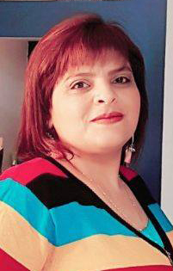
Christian Witness: Children of One Father
My name is Nihal Nasser. I am from the village of Yafa-An Nasirat in Lower Galilee, a village located near Nazareth, where the Angel Gabriel announced to Mary that she would be the mother of the Messiah.
I belong to the Latin Church (Latin = Western Roman Catholic as opposed to other Eastern Catholic traditions.) and I am a parishioner in my village church. The history of the parish goes back to 1862. The construction of the parish building began in 1868 and it was completed in 1986. Today, the parish consists of approximately 360 Latin-rite families, with approximately 50 of these families living outside the village boundaries. We have 1,150 parishioners. There is also a parish school in our village, which was founded in 1868 and serves townspeople from many different Christian churches and non-Christians as well. In it, five hundred and forty students are receiving their education today.
There are many active and lively groups in this parish such as Scouts since 2016, the Legion of Mary, the Marian Confraternity, Saint Anthony's Confraternity, and since 2000, the Neo-Catechumenal communities, plus other groups.
The townspeople from all denominations participate in these groups and their activities. During the Easter/Pascha celebrations, parishioners of different communions exchange greetings following the Easter liturgical celebrations, with Latin parishioners greeting Greek Orthodox parishioners and vice versa.
I grew up in this parish and always had the desire to search for True Love. In 2014, I participated in the Life in the Spirit Seminar, with the Jesus Is Alive ecumenical community in Amman. I returned from this seminar with a desire to join a community with the conviction that I must belong to a community in order to grow in my spiritual life. Since that day I have belonged to the Jesus Is Alive community.
For a while, during my university studies, I was not participating in the Divine Liturgy on Sunday in my parish. By committing to the Jesus Is Alive community, however, I was also committing myself to my church, this being one of the elements of the commitment to Jesus Is Alive. As a result, this brought me back to my village parish, to participate in the Divine Liturgy weekly and join in the feasts and religious ceremonies. This commitment reinforced my sense of belonging to the one Church, rather than being a member of a community which is separate from my parish.
The participation by various Christians (Latin or otherwise) in the various events and activities of the parish enhances the sense of ecumenism and of unity, such that we know that we are the children of One Father and that we are one church despite our different Church traditions.

Day 7: Monday, January 24
Matthew 2:11 “Then, opening their treasure chests, they offered him gifts of gold, frankincense, and myrrh.”
The gifts of communion
Reading: Hosea 6:1-6 For I desire steadfast love not sacrifice.
Reflection: In our journey to Bethlehem, the city of bread, we contemplate the wise men who came to pay homage to the Christ-child. They opened their treasures, and offered the new-born king their gifts of gold, frankincense, and myrrh.
Our historical divisions, and our preoccupation with worldly matters, have broken us apart. So, what gifts have we prepared to offer to the king who comes to illuminate our lives and lead us to the grace of unity? We know that God does not want our riches or burnt offerings, but rather that his power works through our poverty: “I have no silver or gold.” The Lord desires our beating and loving hearts: hearts full of love for him and for our brothers and sisters in Christ from whom we are separated; hearts flowing with acts of mercy; and hearts truly penitent and desiring change.
Let us then prepare for him the gift of a heart full of love. Kneeling in worship requires hearts that are contrite for the sin that divides us and obedient to the One we serve. This obedience revives, heals, and reconciles everything that is broken or wounded in us, around us, and among us as Christians.
Christ has already given the gift of unity to his Church. In the Sword of the Spirit, we grow in communion as we share the graces our different traditions have received, acknowledging that the source of all our gifts is the Lord.
Prayer: All praise, glory and thanksgiving to you, O God. You have revealed yourself in the revelation of your Son both to those who have long awaited your coming, and to those who were not expecting you. You know the suffering that surrounds us, the pain caused by our divisions. You see the world struggling and the deteriorating situation in the Middle East today – the place where you chose to be born, which was sanctified by your presence. Give all the members of our communities the will and the means to work towards the transformation of this world and to offer each other gifts that may nurture our communion. Grant us your endless gifts and blessings. Receive our prayer in the name of your Son Jesus Christ who lives and reigns with you and the Holy Spirit. Amen.

Christian Witness: Fully Committed
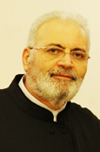
Fr. Georges Abdallah is a member of The People of God community and is a priest of the Antiochian Syriac Orthodox Church.
The first apostolic seat established in Christianity was in Antioch and was founded by St. Peter. It had a primordial place among the Eastern and Western Churches and from there the name “Universal Church” was launched. It had one recognized patriarchate, its head until the year 518 AD, after which new patriarchates branched out.
The Syriacs before Christ were called Arameans, referring to Aram, the fifth son of Shem, the son of Noah, the ancestor of all Semitic peoples. After Christ, the word “Syriac” was used to refer to the Arameans who had accepted the Christian faith and thereafter the word “Syriac” meant “Christian.”
Those who embrace the Syriac Church are spread out today across India, the Arab countries (Lebanon, Syria, Jordan, Egypt, Iraq, the Gulf), Turkey, Europe, North and South America and Australia. Today, the Syriac Church is headed by His Holiness Mor Ignatius Aphrem II, who is the one hundred and twenty-second patriarch among the recognized patriarchs. His seat is in Damascus, the capital of Syria. In India, Mafrian (Catholicos), is the local highest authority in the Syriac Church in India and is subject to the authority of His Holiness the Antiochian Patriarch.
It is one of the four sister churches in unity and faith that also includes the Coptic, Armenian and Abyssinian (Ethiopia and Eritrea) Churches. These churches, along with the Syriac Orthodox Church, rejected the Council of Chalcedon and continued to adhere to teachings of the three councils – of Nicaea (325 A.D.) Constantinople (381 A.D.) and Ephesus (431 A.D.).
Regarding its relations with other churches – today strong and solid love prevail, mutual respect, understanding, and rapprochement. With the Chalcedonian Orthodox Churches, the relations between the Syriac Church and the Greek Orthodox Church in Damascus and the Arab countries are solid and strong, dominated by love and understanding. Good relations with the Protestant churches arose when the Syriac Church joined the World Council of Churches in 1960. The Syriac Orthodox Church also has strong relations with the Middle East Council of Churches and is one of the founding churches of this Council.
As for the relations with the Catholic Churches – in the twentieth century, after the centuries-long break starting in 451 A.D. several meetings took place between the Syriac Antiochian See and the Latin Roman See, starting with Pope Paul VI in 1971 and continuing with Pope John Paul II in two meetings, the last of which, in 1984, issued a joint statement by Syriac Patriarch Ignatius Zakka I and Pope John Paul II which acknowledged the unity of the Nicaean faith and that the schisms that occurred through the ages do not affect the essence of faith or touch it. It acknowledges that the source of these differences was a misunderstanding and not a disharmony due to the incongruity in the idiomatic expressions, and that accordingly there is no real basis for those painful divisions between the two sees that have arisen about the doctrine of the Incarnation. It was agreed, as a result, that the members of the two churches were allowed to practice the ecclesiastical sacraments in the mutual churches in the diaspora, where there is no availability for the believers to practice them in their own churches, due to long distances or absence of the mother church.
As for my personal experience, for forty years now I have been a publicly committed member of the People of God community in Lebanon. The life of the community in Lebanon had a great impact on me as it made me a person open to the brothers in other churches instead of being closed in on myself and reticent to make a covenant with my brothers in the community. Here I experienced ecumenical life in its depth through our love for and service to each other as one body and living as a community of disciples on mission.
The People of God community also had a profound and good influence in discerning my priestly vocation through the support I received and the fraternal care that the brothers surrounded me with. Today, I am a 100% priest of the Lord in the Syriac Orthodox Church and a fully committed member in the People of God community, to live and serve the call fully as a group of 100% disciples on mission without causing any division or disturbance in my relationship with my church or the community. I thank the Lord for having surrounded me with a “wreath of righteous people” and for inviting me to be a member of this community where I can live true ecumenism freely and with pure and unblemished love in which we respect the heritage of our churches, enrich our traditions, and learn from them until we reach the complete unity that Jesus prayed for, "that they may be one."

Day 8: Tuesday, January 25
Matthew 2:12 “They left for their own country by another road.”
Beyond the familiar routes of separation to God’s new paths
Reading: Psalms 16:11 You show me the path of life.
Reflection: We do not know what the wise men thought – they who were experts in astronomy and navigation – when they were warned to return by another road. They may well have been very confused, but the same light that illumined their journey showed them that there was another road, another possibility. They were called to change direction.
We often find ourselves bound by our familiar ways of doing things and of seeing the world. When these ways or “roads” are closed, we wonder how to proceed and continue the journey. God’s divine providence is always there to show us that there is another way prepared for us. God is there to renew his covenant and lift us up from the frustration we experience when we meet an obstacle. We must trust that the everlasting One who gave us the light, can always find a way forward when our ways and paths are blocked. A fresh start is always possible when we are willing and open to the work of the Spirit.
As Christians in the Sword of the Spirit we share God´s call to walk together as pilgrim companions. We look to the future with discernment, humility, and courage in search of new ways so that we can continue to shine the light of the Gospel with renewed fervor and welcome each other as Christ welcomed us for the glory of God.
Prayer: Gracious God, when we only know one way and we think we must return to it, and when we think that all roads are blocked, and we fall into despair, we always find you there. You are the God of renewed promises. We find you creating a new path before us, one that we did not expect. We thank you because you exceed our expectations. We thank you for your wisdom that surpasses our understanding. We thank you because your creative paths open unforeseen possibilities. If we search our maps and find no route, nonetheless we always find you, who lead us by a yet more excellent way. We pray through Jesus Christ our Lord, in the fellowship of the Holy Spirit, that you will always lead us back to you. Amen.

Christian Witness: I Cannot but Thank God
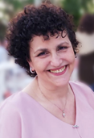
Ferial Baz is a member of The People of God community in Beirut.
My father was Greek Orthodox and my mother Maronite (Catholic). I grew up going to both Churches but being rooted in neither of them. I enjoyed celebrating Palm Sunday and Pascha (Easter) twice every year. That was about everything I knew of Christianity at that time.
While still a pre-teen and being an avid reader, I had an annual subscription at a Baptist library where I could borrow books and read them anytime I wanted to. There I was introduced to a different version of Christianity: The Baptist Church. I was attracted to the youth meetings, and I started reading the Bible on my own. Little by little I grew attached to the Baptist Church and became a faithful member of it. There I met my husband, who, like me, was also a cradle Orthodox. In 1984, we got married and eventually had three boys and a girl.
Early in our second year of marriage, we attended the Life in the Spirit Seminar, having started visiting the public meetings of the People of God back in 1977. Living in war-torn Lebanon during the 1970s and early 1980s, we were unable to join the People of God until after the war.
However, after the birth of our third son, I started having second thoughts concerning Church. I was feeling dry inside. There was something I was missing. My husband was equally experiencing a personal crisis. After consulting with some leaders in the People of God, we were advised to explore the possibility of attending the Orthodox Church, since this was the Church into which we were originally baptized.
Slowly, we heeded this advice. The first year, everything seemed so foreign to us, and to our children as well. They missed their friends at Sunday school.
But little by little, the dryness in my heart was lessening. The worship, the psalms, the lyrics of the chants, the litanies and all the beautiful prayers of the Orthodox Church started growing on me and opening me up to a new dimension in worship, calling me to explore new depths in my relationship with the Lord and with the Orthodox Church.
Now, thirty years after this experience, I cannot but thank God for the Baptist Church, who first opened my heart to the love of God and to the love of his Word. I also thank the Lord for the wisdom he has endowed my brethren in the People of God in order to bring me back to the Church I belong to now.
In the Orthodox Church, our children got baptized, and grew up not only in the midst of the community life of the People of God but also in our Orthodox parish where two of them became cantors, and where I am a reader, while my husband serves on the administrative committee.

